**Numeric Sequence Calculator User Guide**

**Introduction**  
The document describes the application Numeric Sequence Calculator. Chapters showcase the functionality of the application and steps for its usage by the end user.

**Overview**The Numeric Sequence Calculator application is a simple application that demonstrate user the different type of number sequences for a particular number entered by the user.

**Using the Application**

1. Open the website by entering URL in the browser
2. Enter the number in the area provide in from of text ‘Number:’ you desire to generate the numeric sequence and click on ‘Submit’ button or press ‘Enter’ key. Kindly refer image below  
   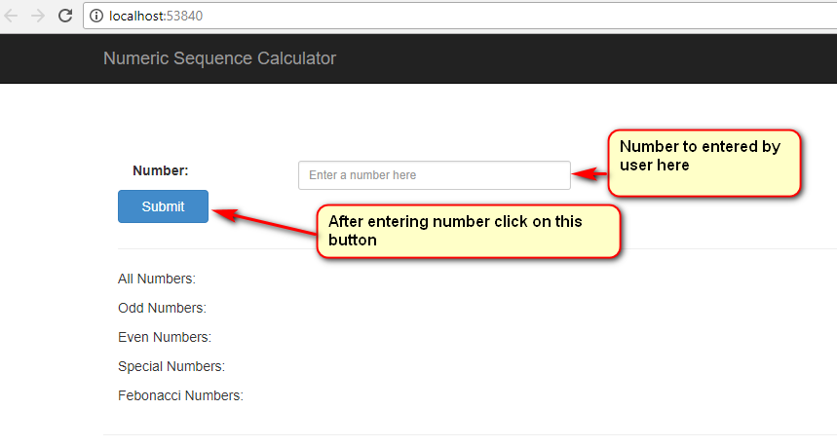
3. After clicking on ‘Submit’ button or pressing ‘Enter’ key the result of different number sequence will be displayed as shown in image below.  
   